`


Analysis of the impact of changing propulsion systems in urban transport buses based on EU-funded projects

Final report - July 2024

Research team at the Centre for EU Transport Projects:
Edyta Boratyńska-Karpiej

Dariusz Giziński
Anna Kiwiel
Marta Lorczyk
Expert supervision:
Paweł Engel

List of abbreviations:
AFIR - Alternative Fuels Infrastructure Regulation
CNG – compressed natural gas
CEUTP – Centre for EU Transport Projects
EV – electric vehicle
HVO - hydrogenated vegetable oil
LNG – liquefied natural gas
LPG – liquefied petroleum gas
Bn – billion
RR – Renewable resource
OPI&E – Operational Programme Infrastructure and Environment
SRG - Strategy for Responsible Growth
TCO – total costs of ownership
TEN-T - Trans-European Transport Network
UE – European Union

Contents
List of abbreviations: 2
Introduction and methodological assumptions 4
Objectives and application of the analysis. 5
Actuality 7
Formal and legal conditions 9
Zero-emission urban transport 12
Statistics data 13
Case study – Cracow 14
EU climate policy - why are we looking for alternatives to diesel and do we have any alternatives? 16
Obligations imposed on EU countries 16
What alternatives to diesel do we have and what are their characteristics? 19
Alternative fuels - electricity 20
Alternative fuels – hydrogen 20
Alternative fuels – natural gas (CNG and LNG) 21
Alternative fuels – sulphur-free diesel and petrol 22
Alternative fuels – Hydrogenated vegetable oil (HVO) 23
Alternative Fuels Infrastructure Regulation (AFIR) – what you need to know 23
Analysis of the total costs of ownership of buses with different propulsion types, including vehicles purchased from EU-funded projects 24
Public acceptance of change 30
In lieu of a summary 42
Conclusions 44
Appendix 1 Description of the survey methodology 47

Introduction and methodological assumptions
The dynamic development of transport is one of the main elements conditioning the development of the economy through the realisation of activities in the transportation of goods and commodities. Transport is also extremely important from the point of view of society and the quality of human life, as it ensures the possibility of free movement. However, the transport-related activities undertaken affect everyone's quality of life, so the drive to reduce emissions and fuel consumption are the most important factors driving change in the mobility sector. These trends are forcing the use of innovative solutions and the search for solutions outside the traditional value chain. Today, transport significantly influences the economic growth and economic importance of every country. The use of economically efficient goods and environmentally friendly vehicles in the transport of manufactured goods allows lower prices for their production and distribution. This allows manufacturers to gain new markets by making their products more economically accessible to different social strata in different regions and countries. The relationship between the costs of producing tangible goods, their distribution and their use in many cases depends on the fuel consumption of the vehicles used to transport them.
Currently, the largest proportion of buses operates in urban transport and there are buses equipped with conventional diesel powertrains. A positive note is the increasing share of buses powered by alternative fuels year-on-year. The increase in the number of low-emission vehicles is linked to an increase in the environmental awareness of the population, but also to the conditions set by the European Commission allocating funds. Noise levels, environmental protection and air quality are the main reasons why Polish cities are seeking to replace conventional buses with low-emission vehicles.
The Centre for EU Transport Projects, as the Intermediate Body
for the Operational Programme Infrastructure and Environment 2014-2020 and the Operational Programme Eastern Poland 2014-2020 and as the Implementing Authority for the Connecting Europe Facility (CEF), aims to implement projects that are the most effective and useful for all groups of society.
Taking this into account, CEUTP decided to analyse the total costs of ownership and efficiency of electric, hydrogen, hybrid and conventional urban buses.

Objectives and application of the analysis.
The cost of owning and operating urban buses depends on the type of propulsion system. Electric-powered vehicles, for example, require the replacement of batteries during the life of the bus. Operators who decide to purchase low-emission vehicles should consider, among other things, the cost of additional infrastructure for electric buses. This often involves adapting bus depots or bus stops to install charging facilities. The TCO provides an estimate of the total costs of a vehicle associated with its purchase, use and decommissioning.
The main analysis objective of the study was to analyse the acquisition and operating costs of urban buses with different types of powertrains, using the total costs of ownership (TCO) method.
The main objective was achieved by estimating the amount of the following costs considering the economic life-cycle period of each vehicle type:
- vehicle purchase cost,
- cost of fuel/electricity consumption,
- cost of repairs,
- cost of battery replacement,
- cost of charging/refuelling infrastructure.
The study was based on projects financed by EU funds under the Operational Programme Infrastructure and Environment 2014-2020. A detailed description of the methodology used can be found in Appendix 1 to the report.
Lessons learned from the 2014-2020 experience may be relevant to provide recommendations for use in the implementation of projects in the longer term.

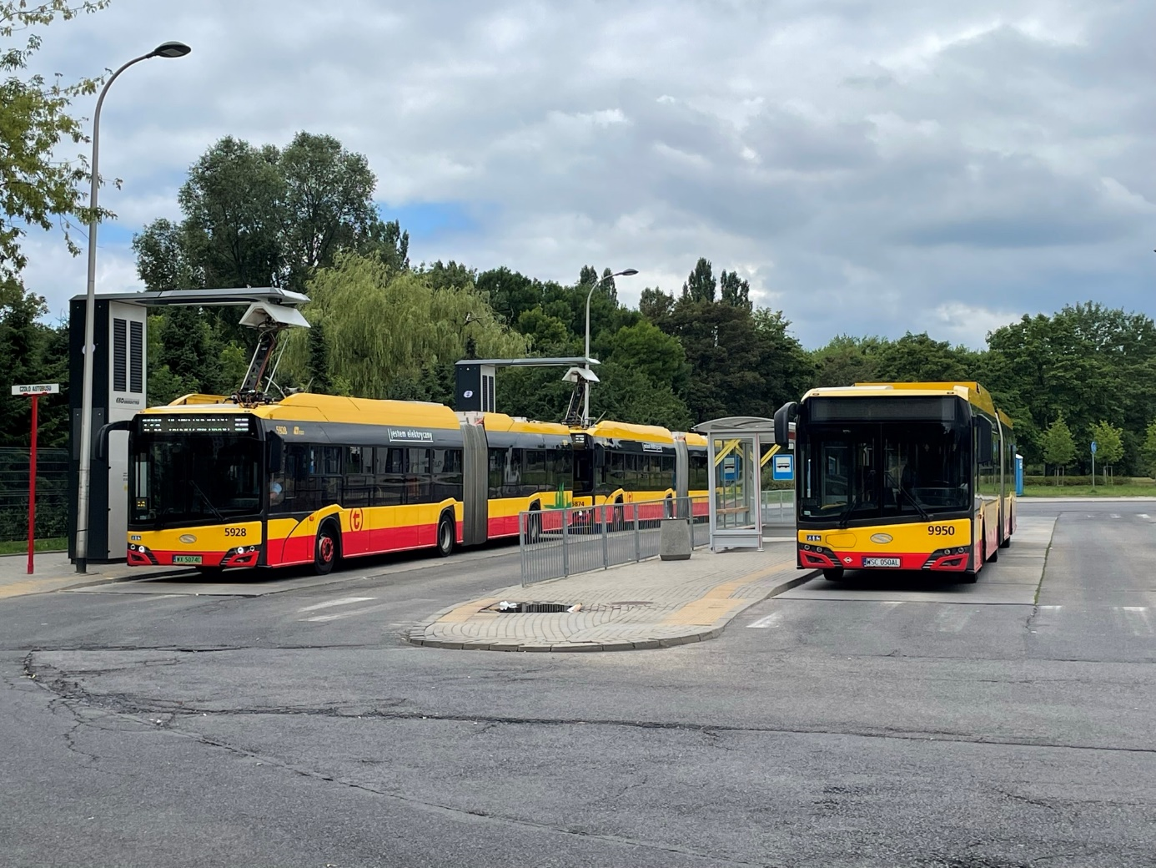
Figure 1 A bus terminus in Warsaw. Source: CEUTP.

Actuality
Recent scientific reports indicate that the global climate is undergoing unprecedented changes. Global warming is increasingly - often irreversibly - affecting ocean currents, precipitation and wind circulation in all regions of the world. Higher temperatures and more extreme weather events are also putting a huge cost on the EU economy and making it harder for countries to produce food.
The facts speak for themselves:
- over the past 40 years, extreme weather and climate events have caused more than €487 billion in financial losses in the EU;
- between 1980 and 2020, more than 138,000 people in the EU lost their lives due to extreme weather and climate-related events;
- the economic cost of river floods in Europe exceeds EUR 5 billion per year on average;
- forest fires cause economic damage of around EUR 2 billion in the EU every year.
Electromobility is one of the key areas of action for environmental protection. The development of this sector is driven not only by environmental and climate conditions, but also by innovative solutions that change the competitiveness of industries and modify the global map of raw material dependence. Continued work in this area will have a positive impact not only on the automotive industry, but also on the economy as a whole.
To meet the high expectations of the transport sector, the Ministry of Climate and Environment has created a package of legal regulations to support the development of electromobility and the use of other alternative fuels (natural gas in the form of LNG and CNG) in the transport sector in Poland. Documents pertaining to this topic envisage a number of incentives for drivers and entrepreneurs, as well as the development of charging infrastructure for electric cars and CNG/LNG refuelling. Among them, the Electromobility Development Programme, which is the flagship project of the Strategy for Responsible Growth, is crucial. The implementation of the objectives of the SRG and the Electromobility Development Programme was based on the following strategic documents:
- Electromobility Development Plan "Energy into the Future," adopted by the Council of Ministers on 16 March 2017.
The Plan defines the benefits associated with the widespread use of electric vehicles in our country and identifies the economic and industrial potential of the area.
- The National Policy Framework for the Development of Alternative Fuels Infrastructure, adopted by the Council of Ministers of 29 March 2017.
This document implements European regulations concerning, among other things, the conditions for building infrastructure for alternative fuels in 32 Polish agglomerations.
- The Act on Electromobility and Alternative Fuels of 11 January 2018.
This regulation is intended to stimulate the development of electromobility and popularise the use of other alternative fuels (including LNG and CNG) in the transport sector in Poland.
- The Act establishing the Low Emission Transport Fund (FNT), i.e. the Act of 6 June 2018 amending the Act on bio-components and liquid biofuels and certain other acts.
The task of the Low Emission Transport Fund is to finance projects related to the development of electromobility and transport based on alternative fuels.
Through the introduction of new legislation dedicated to electromobility, it was forecast that in 2020, in 32 selected agglomerations:
- in the electric vehicle segment:
  - 50,000 vehicles will be on the roads,
  - 6,000 points with normal charging power will be set up,
  - 400 high-capacity charging points will be set up,
- in the CNG-fuelled cars segment:
  - 3,000 vehicles will be on the road,
  - 70 refuelling points will be built.
Nationwide in 2025:
- in the segment of electric-powered cars:
  - 1 million electric vehicles will be on the roads,
- in the segment of CNG-powered cars:
  - 54,000 vehicles will be on the road,
  - 32 charging points will be available along the TEN-T core network,
- in the segment of LNG-fuelled cars:
  - 3,000 vehicles will be on the road
  - 14 LNG refuelling points will be built along the TEN-T core network,
  - LNG bunkering facilities will be in operation in the ports of: Gdańsk, Gdynia, Szczecin and Świnoujście.

Formal and legal conditions
Modern technological developments are enabling modern states to take increasingly extensive measures to develop global climate security. In line with the European "Fit for 55" initiative, the European Union has set itself the goal of achieving climate neutrality by 2050. The ambitious plans entail concrete measures to which the organisation has committed the Member States. One of the important issues for the realisation of the European Green Deal is electromobility, i.e. the broad spectrum of issues related to the use of electric vehicles. The gradual reduction in the popularity of internal combustion cars in favour of "electrics" is primarily aimed at reducing the release of carbon dioxide and other environmentally harmful compounds into the atmosphere. The Polish legal order in this regard is primarily governed by the Act of 11 January 2018 on electromobility and alternative fuels.
According to Article 1 of the said act, it sets out:
1) rules for the development and operation of infrastructure for the use of alternative fuels in transport, hereinafter referred to as "alternative fuels infrastructure", including the technical requirements to be met by this infrastructure;
2) obligations of public entities with regard to the development of alternative fuels infrastructure;
3) information obligations regarding alternative fuels;
4) Conditions for the functioning of clean transport zones;
5) National policy framework for the development of alternative fuels infrastructure and the manner of its implementation.
The law defines many specific issues related to electromobility. A catalogue of legal definitions can be found in Article 2, and the entire glossary has as many as 29 definitions, including, among others, an explanation of such phrases as:
Alternative fuels – electricity or fuels used for propulsion of engines:
a) motor vehicles as defined in Article 2(32) of the Act of 20 June 1997. - Road Traffic Law,
b) rail vehicles,
c) vessels
– constituting a substitute for fuels derived from crude oil or obtained in the process of its processing, in particular hydrogen, liquid biofuels, synthetic and paraffinic fuels, CNG, including that derived from biomethane, LNG, including that derived from biomethane, or LPG;
Charging – the consumption of electricity by a) an electric vehicle, a hybrid vehicle, a zero-emission bus, b) a motor vehicle, a moped, a bicycle or a bicycle cart, which is not an electric vehicle, as of 20 June 1997. - Road Traffic Law - for the propulsion of this vehicle;
Electric vehicle – a motor vehicle within the meaning of Article 2, point 33 of the Act of 20 June 1997. - Road Traffic Law, using for propulsion exclusively electrical energy accumulated by connection to an external resource;
Hybrid vehicle – a motor vehicle within the meaning of Article 2, point 33 of the Law of 20 June 1997. - Road Traffic Law, with internal combustion and electric propulsion, in which electric energy is accumulated by connecting to an external resource;
Charging point – a facility for the charging of a single electric vehicle, a hybrid vehicle and a zero-emission bus, as well as a location where the battery used for propulsion of that vehicle is replaced or recharged;
The Act sets out the normative basis on which electric, hybrid, gas and hydrogen vehicles exist in the legal space. Also relevant for the purposes of urban administration is the definition of zero-emission buses contained in Article 2, according to which it is ‘a bus as defined in Article 2(41) of the Act of 20 June 1997 – Road Traffic Law (Journal of Laws of 2021, item 450, as amended2 ) and a trolleybus within the meaning of Article 2(83) of that Act, using for propulsion electrical energy, including energy generated from hydrogen in fuel cells installed in them, or exclusively an engine whose duty cycle does not lead to emissions of greenhouse gases or other substances covered by the system for management of emissions of greenhouse gases and other substances referred to in the Act of 17 July 2009 on the system for management of emissions of greenhouse gases and other substances (Journal of Laws of 2022, item 673);’.
The Act on Electromobility and Alternative Fuels is a national law, but due to the subject matter of the regulation of interest to the EU, it is an act implementing EU law. The Act implements Directive 2014/94/EU of the European Parliament and of the Council of 22 October 2014 on the development of alternative fuel infrastructure (Official Journal of the EU L 307 of 28.10.2014, page 1); Directive 2019/1161 of the European Parliament and of the Council (EU) of 20 June 2019 amending Directive 2009/33/EC on the promotion of clean and energy-efficient road transport vehicles (Official Journal of the EU L 188 of 12.07. 2019, page 116), Directive (EU) 2019/944 of the European Parliament and of the Council of 5 June 2019 on common rules for the internal market in electricity and amending Directive 2012/27/EU (Official Journal of the EU L 158 of 14.06.2019, page 125) and Directive (EU) 2018/844 of the European Parliament and of the Council of 30 May 2018 amending Directive 2010/31/EU on the energy performance of Buildings and Directive 2012/27/EU on energy efficiency (Official Journal of the EU L 156 of 19.06.2018, page 75).
The normative scope of the act under discussion is overly broad, including many detailed regulations related to technical issues of electromobility operation. The act specifies, among other things, the obligations of the operator of a public charging station (Article 3), its liability for damage caused by the failure of a public charging station to meet technical requirements (Article 5) and the right of the operator of a public charging station to perform the tasks of a charging service provider (Article 6). The act in question also regulates the civil rights of individuals who contract with the station operator. According to Article 7, the charging service provider may not make the provision of the charging service conditional on the prior conclusion of a contract in written, paper or electronic form by the user of the electric vehicle or hybrid vehicle.
One of the primary obligations of the operator of a public charging station is to ensure that the electricity supplied to the public charging station is used Exclusively for the purpose of:
1) charging;
2) charging or replacing the battery used for propulsion of an electric vehicle, a hybrid vehicle, a zero-emission bus or a motor vehicle, as defined in Article 2, point 32 of the Act of 20 June 1997. - Road Traffic Law, which is not an electric vehicle;
3) ensuring the operation of this station. The Act also provides for the relevant requirements to be met by charging stations. According to Article 13, charging stations, charging points that are part of the charging infrastructure of road public transport and points for supplying vessels with electricity from land meet the technical and operational requirements specified in particular in the Polish Standards, ensuring their safe use, including fire safety, safe operation of electricity networks and access to charging stations for disabled persons. It is also important that, prior to the construction of the charging station, the investor applies to the President of the Office of Technical Inspection for an opinion on the compliance of the technical documentation of the designed station with the relevant technical requirements. The President of the UDT has 30 days to consider the application and issue an opinion.

Zero-emission urban transport
The definition of a zero-emission bus is set out in Article 2(1) of the Electromobility and Alternative Fuels Act. According to this definition, a zero-emission bus uses, for propulsion, electricity generated from hydrogen in fuel cells installed in the bus, or only an engine whose duty cycle does not lead to emissions of greenhouse gases or other substances covered by the greenhouse gas management system. The definition also includes trolleybuses, while hybrid buses are excluded as emitting pollutants into the atmosphere.
Trolleybuses are the oldest means of public transport of the above, in terms of experience of use, both in our country and in other European countries. In the 1960s, ten trolleybus service lines were operating in Warsaw. With the development of diesel-propulsion buses, characterised among other things by lower operating costs, they were decommissioned. Their reintroduction would require the creation of an appropriate network infrastructure necessary for power supply. Currently, trolleybuses run in Poland in cities such as Lublin, Gdynia and Tychy.
Electric buses, whose history of use is not as long as trolleybuses, after a phase of numerous tests in many cities, have quite recently been massively integrated into regular public transport fleets. In order to accelerate the spread of this means of transport in our country, the state is stimulating measures to create a market for them, which will allow the development of production and, consequently, lead to a reduction in the price of electric buses. The purchase price of such a fleet today is about 2-3 times higher than that of a combustion bus. In addition, the cost has to consider the necessity of building charging infrastructure, adaptation of bus bases to service electric buses, not to mention the battery life limited to about 8 years. After which period they need to be replaced. Used batteries, batteries need to be disposed of. This significant problem, in view of the short experience with electric buses, has not yet seen a systemic solution.
A propulsion system based on hydrogen fuel cells should be regarded as a completely emerging, yet promising technology. The market in this area in our country has not yet developed. The situation is similar in other European countries. The most advanced solutions are being developed in Japan. The first hydrogen-powered bus in Poland was produced by the Ursus Bus company. The first refuelling stations are now emerging.

Statistics data
Based on data from the Polish New Mobility Association, as of 31 May 2024, the zero-emission bus fleet in Poland amounted to 1323 units (of which all-electric vehicles accounted for 1269 units and hydrogen vehicles for 54 units).

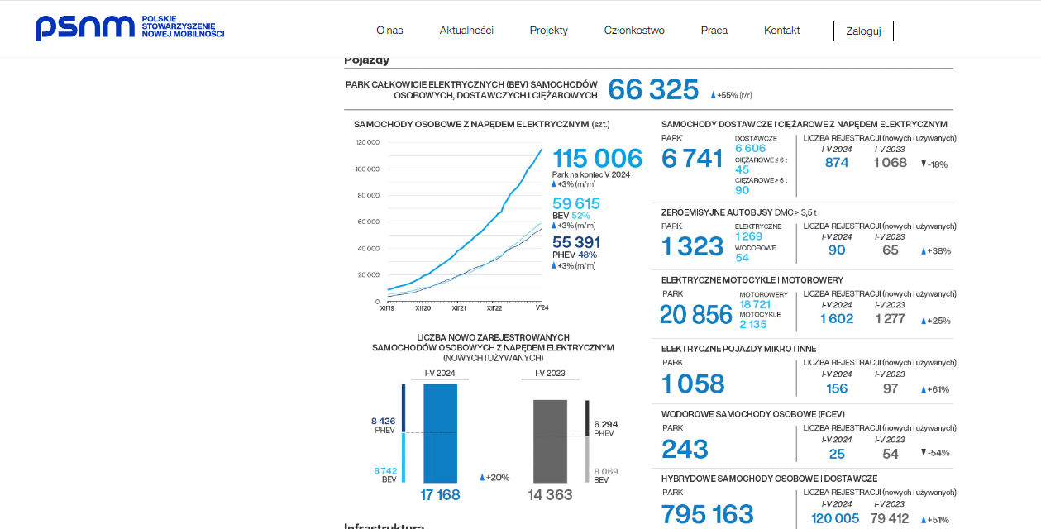
source: www.psnm.org
According to experts, it can be assumed that it takes one year from contract to registration, so by adding this time to the date given, we have the end of 2020.
The same source concludes as of 31 December 2020, the electric bus fleet in Poland numbered 430 units. Hydrogen ones were not there yet.
So the changes are visible at least in the statistics: as of 1 February 2020, 54 hydrogen buses and 839 electric buses have been contracted and delivered. We will write about whether the public also sees them in the section on the results of the quantitative survey among the public.
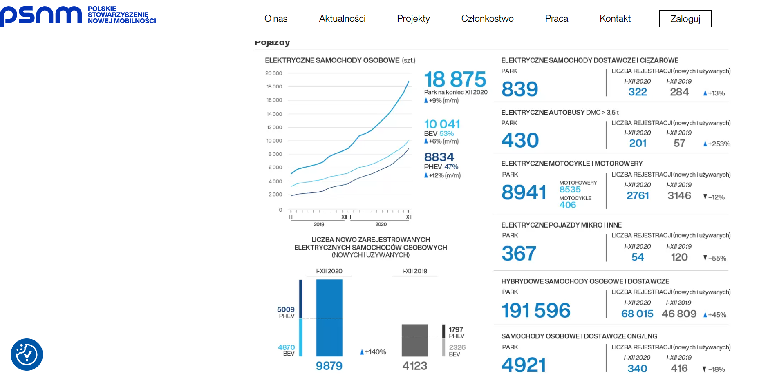
source: www.psnm.org

Case study – Cracow
Cracow was the first of the large Polish cities to start testing electric buses. It is the first city in Poland to have regular routes served by electric buses and a station for charging the buses using a pantograph. It was also the inhabitants of the capital of the Małopolska Province that had the first opportunity to travel on an articulated electric bus in Poland. In deciding to operate electric buses, the city of Cracow is looking for solutions to develop public transport on the one hand, and to meet increasingly stringent environmental standards on the other. The use of electric buses for urban transport services is in line with Cracow's strategic policy of low-emission and reduction of air pollution by urban transport. With a view to meeting the requirements of the Act on Electromobility and Alternative Fuels, the Cracow authorities have adopted general assumptions for increasing the number of city bus fleets. From these assumptions, it follows that such buses must be purchased in the coming years, The Cracow authorities plan that by 2025, one third of urban buses will be electrically powered and the remainder will meet the combustion standard of at least Euro 6 or will use a hybrid propulsion system. The implementation of this plan could secure the city's position as one of the leaders in electromobility development in Poland.
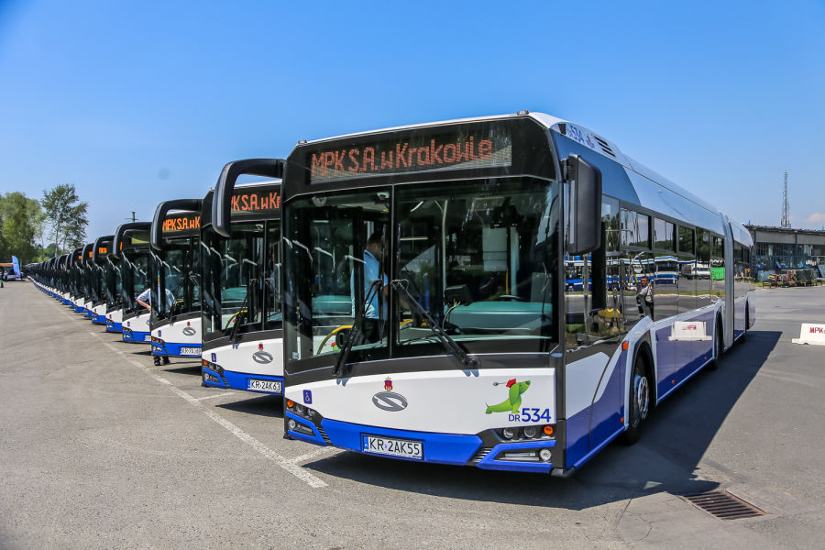
Figure 2 Solaris buses owned by MPK Cracow. Source: https://www.krakow.pl/aktualnosci/214802,1912,komunikat,solaris_dostawca_38_nowych_autobusow_przegubowych_.html

EU climate policy - why are we looking for alternatives to diesel and do we have any alternatives?

Obligations imposed on EU countries
At the European Council in December 2019, EU leaders agreed that the EU should achieve climate neutrality by 2050.
Climate neutrality is emitting only as much greenhouse gas into the atmosphere as can be absorbed by nature, i.e. forests, oceans and soil. In order to achieve such zero emissions by 2050, EU countries will have to significantly reduce their greenhouse gas emissions and find ways to compensate for the remaining unavoidable emissions.
In its conclusions, the European Council stressed that moving towards climate neutrality opens up significant opportunities in terms of:
- economic growth
- markets and employment
- technological development.
The EU leaders asked the European Commission to continue its work on a European Green Deal. They also recognised that the green transition should not only be cost-effective, but also socially sustainable and equitable.
Equally a year later, in December 2020, EU leaders made further progress towards climate neutrality. They agreed that, as an intermediate step towards the 2050 target, EU greenhouse gas emissions should be cut by more than half (compared to 1990) by 2030.
By 2030, EU emissions will be reduced by at least 55%. This target is significantly higher than the EU's 2030 target - agreed in 2014 - which called for a 40% reduction in emissions. Leaders have asked the European Commission to propose legislation so that countries can meet the 2030 target, including by:
- improving green financing standards
- strengthening the EU Emissions Trading Scheme
- driving climate-friendly innovation
- ensuring equity and cost-effectiveness.
In July 2021, one month after its adoption by the Council, the European Climate Law came into force. It is a key element of the European Green Deal. It represents the legal commitment of Member States to achieve the 2030 and 2050 climate targets.
The act sets out a framework of actions that the EU and its Member States must take to gradually reduce emissions and achieve climate neutrality by 2050.
Also in June 2021, the Council approved conclusions endorsing the EU's climate change adaptation strategy presented by the European Commission. The strategy sets out a long-term vision for EU society to become climate resilient and fully adapted to its inevitable impacts by 2050.
Council approves new EU climate change adaptation strategy (press release 10 June 2021)
Another key element of the EU's climate neutrality efforts is the Fit for 55 package. This package, which alongside new initiatives includes proposals to amend existing legislation, is the EU's main tool for codifying climate targets.
It contains provisions on:
- energy
- transport
- emissions trading and reduction
- land and forestry use.
While emissions are increasing in some sectors, such as international aviation and transport, other sectors have significantly reduced their emissions since 1990. At the forefront is the energy industry, where emissions have fallen by 47%. By 2020, the EU's emissions have decreased by 30% compared to 1990 levels.
Part of the Green Deal, proposed in 2021 by the European Commission, is a package of new and updated legislation called Fit for 55. The Council of the European Union has approved the key directives and regulations of the package, which were voted by the European Parliament. The legislation that is part of Fit for 55 will raise the EU's 2030 reduction target for the road transport sector from 29% to 40% compared to 2005 (EU Parliament and Council Regulation 2018/842). Fit for 55 also provides for progressive emission reduction targets for cars and vans for 2030 and a 100% target for 2035 for new vehicles of this type (Regulation of the European Parliament and of the EU Council 019/631 + EU Commission Delegated Regulation 2020/22). From 2030 onwards, new cars are to emit 37.5 per cent less CO₂ on average compared to 2021 for cars and 31 per cent less on average for vans. Limits for trucks and other heavy vehicles were adopted in June 2019. The legislation obliges manufacturers to reduce CO₂ emissions by an average of 15% from 2025 and 30% from 2030 compared to 2019.
Based on the Fit for 55 package, the President of the European Parliament and the President of the EU Council approved the Corporate Sustainability Reporting Directive (CSRD: Corporate Sustainability Reporting Directive) (EU Parliament and Council Directive 2022/2464). According to it, all large entities and small and medium-sized listed companies will present information on environmental, social and human rights issues and corporate governance in their management report. The directive is intended to set standards for reporting on these areas so that they are measurable, objective and comparable. Companies will be required to report in a much broader way than is currently the case based on the Non-Financial Reporting Directive (NFRD) (European Parliament and Council Directive 2014/95/EU). Until the end of 2024, 150 companies in Poland obliged under the current NFRD are covered by the CSRD. From 2025, more than 3,500 Polish companies will be affected by the new regulations and reporting obligations. From 1 January 2024, large public interest companies with more than 500 employees subject to the NFRD will be covered by the CSRD. From 1 January 2025: large companies not currently subject to the NFRD, with more than 250 employees, and/or with EUR 40 million turnover and/or EUR 20 million balance sheet total. From 1 January 2026: small and medium-sized listed companies and other companies. Small and medium-sized companies may defer reporting until 2028. The directive was published in the Official Journal of the EU on 16 December 2022. EU member state governments have 18 months to implement these provisions into national law.
For public transport, the European Commission is proposing that all urban buses entering service from 2030 should be zero-emission. The legislation aims to reduce carbon dioxide emissions of heavy-duty vehicles by 40 per cent by 2040.
The transition to a climate-friendly economy will require significant public and private investment. EU countries have committed to allocating 30% of the EU's 2021-2027 and Next Generation EU long-term budget to climate-related projects.
To make the green transition fair, the EU has introduced the Fair Transition Mechanism. It allows financial and technical support to be made available to regions most affected by the transition to a low-carbon economy. Up to €90 billion will be mobilised for this purpose - 30% of total EU spending by 2027 will be allocated to climate-related projects
The EU's efforts to combat climate change are in line with EU and Member States commitments under the Paris Agreement signed in 2015. EU countries support a high level of ambition in the implementation of this international agreement and encourage global partners in international fora and bilaterally to accelerate action against global warming.
The EU, together with its Member States, is the largest global sponsor of climate action. It supports these actions in developing countries to facilitate their Ecological transition and help them cope with the negative effects of climate change.

What alternatives to diesel do we have and what are their characteristics?
Unsurprisingly, diesel remains by far the most popular fuel used in truck fleets and it is not hard to see why. It is widely available, inexpensive and offers excellent driving range. It is the primary fuel of all TIR trucks. But that does not make it perfect.
The cost of diesel is volatile because it is affected by changes in oil prices. 75 per cent of transport directors cite fluctuating oil prices as one of their main Operational concerns, which is why many are looking for alternatives. Particularly because heavy-duty vehicles burn a lot of it.
Alternative fuels can bring a number of business benefits:
- Cost savings - alternative fuels can be cheaper than petrol and diesel.
- Recruiting and retaining drivers - the next generation of drivers is interested in sustainability, and fleets powered by alternative fuels may have more interest among younger drivers.
- Environmental responsibility - alternative fuels produce fewer CO2 emissions than fossil fuels, contributing to sustainability.
- Government incentives - incentives and subsidies for the use of alternative fuels, which can help offset any upfront costs associated with switching to a new fuel.
- Enhanced fuel security - alternative fuels are often produced domestically, which can help reduce dependence on foreign sources.
- Improved vehicle performance - vehicles powered by alternative fuels, such as electricity, can provide improved vehicle acceleration and torque. Electric motors provide maximum torque independent of speed.
In addition to analysing the benefits that alternative fuels offer, it is equally important to verify their availability and cost. An additional factor influencing the decision to switch to this alternative solution is the type of vehicles in your fleet. In turn, the next step is the choice of fuel type.

Alternative fuels - electricity
Electricity is currently the most popular alternative fuel for fleets. Electric vehicles (EVs) are increasingly being chosen by fleets, especially those whose vehicles travel short distances and in urban areas where charging stations are readily available. Despite challenges related to range, commercial fleets are enjoying the savings generated by EVs. Fleets are also opting for electrification to reduce their carbon footprint.
Fleets that cannot immediately invest in electric vehicles are opting for other alternatives. As FleetOwner magazine points out, alternative fuels other than electricity are essential to quickly reduce a fleet's carbon footprint - current internal combustion engines (ICEs) can run on them, or they can be adapted to them.

Alternative fuels – hydrogen
Hydrogen fuel cells – hydrogen fuel cells generate electricity by combining hydrogen with oxygen. When used as a fuel, it burns completely clean, leaving no emissions other than water. Most importantly, it also offers a much better range than a BEV.
It is important to note, however, the ‘colours’ of the hydrogen, which are grey, i.e. produced by reforming natural gas – a reaction using methane and steam, with carbon dioxide as a by-product. Its share of hydrogen production is as high as 96%. From the perspective of the European Green Deal, blue hydrogen, also produced from natural gas, is a better choice, but the resulting CO2 is captured and stored underground.
Green hydrogen, on the other hand, which is produced by renewable resources, is the most appropriate. This leads the EU to plan for electrolysers with a total capacity of 6 GW and production of one million tonnes of renewable hydrogen by 2026. By 2030, 40 GW of electrolysers will support hydrogen power generation in the EU.
Traditionally, hydrogen is used in industrial processes, with transport and fuel cells accounting for a small proportion of consumption. This results in an overwhelmingly low focus on obtaining hydrogen from RES to date. Europe accounts for about 21 per cent of global hydrogen production and is currently dominated by fossil fuels. 94 per cent of hydrogen production comes from fossil fuels, with 54 per cent from natural gas, 31 per cent from oil and 9 per cent from coal. However, efforts are being made to use RES for hydrogen production. An example is Germany, which is actively pursuing its production from electrolysis using wind power.
It is predicted that 15 to 20 million trucks will run on hydrogen by 2050.
However, according to some estimates, hydrogen can be an expensive way to power a fleet – three to four times more expensive than diesel. Furthermore, given that 95% of the world's hydrogen is produced using fossil sources, this also raises sustainability issues.
Added to this is the lack of infrastructure. In order to use hydrogen fuel, hydrogen refuelling stations are needed, and currently the number of these stations across Europe is small. Most locations are being developed in Germany, the UK and the Netherlands.
So, while hydrogen fuel cells are an attractive alternative for transport, large investments and changes in infrastructure will be needed before they become affordable and practical enough for mass deployment.

Alternative fuels – natural gas (CNG and LNG)
Natural gas – comes in CNG and liquefied petroleum gas (LNG) forms. It provides lower exhaust emissions and quieter engine operation compared to diesel fuels. It is widely used in heavy transport.
Of all the natural gas-based alternative fuels for transport, LNG appears to be the most suitable. Natural gas stored in liquid form offers a range of about 1,000 KM and has 10%-20% lower emissions than diesel.
There are also those who believe that it will be widely adopted in the near future. NVGA Europe predicts that LNG trucks will have around 25% market share by 2030.
However, this will require significant infrastructure changes. Although the number of LNG refuelling stations is growing in Europe, it is not yet extensive enough to serve the continent's transport network.
Moreover, although gas may be cheaper than oil, LNG production is expensive. Transport operators will also have to make additional investments, as trucks require additional tanks to use LNG.
There are, however, cases of successful application. In 2015, Parisian retail chain Castorama announced that it would redesign its planning to replace the diesel trucks it used to deliver stock to shops with gas trucks.
Not only did this plan prove successful, but it also managed to reduce the number of trucks needed from seven to six throughout the process.

Alternative fuels – sulphur-free diesel and petrol
Sulphur-free diesel and petrol - used in land and marine transport since 2011. Sulphur-free fuels improve catalytic converter performance, resulting in vehicles emitting significantly less CO₂. As a result, vehicles using these types of fuel emit significantly less carbon dioxide and other pollutants, including sulphur oxides, which are responsible for acid rain and have a negative impact on the environment and human health.
The use of sulphur-free fuels also has a positive impact on the durability and reliability of engines. Sulphur, a component of traditional fuels, contributes to the corrosion of fuel and exhaust system components, thus shortening engine life and increasing vehicle operating costs. Therefore, switching to fuels with a minimum sulphur content is beneficial not only from an environmental point of view, but also in terms of the economy of vehicle use.
In addition, legislation has been introduced in many countries that requires the use of sulphur-free fuels to meet emission standards. These regulations, often supported by initiatives promoting green energy and low-carbon transport, aim to gradually reduce dependence on fossil fuels and accelerate the transition to alternative resources.
In the context of global warming and growing environmental awareness, the development and promotion of sulphur-free diesel and petrol are an important step towards sustainable transport. The ultimate goal is to achieve climate neutrality and reduced sulphur fuels are an important element in a comprehensive approach to achieving this goal.

Alternative fuels – Hydrogenated vegetable oil (HVO)
Hydrogenated vegetable oil (HVO) – although there are many biofuels on the market, most do not meet the practical requirements of long-haul transport, but HVO has definite advantages to be adopted by the industry. Produced by blending hydrogen with vegetable oils (rather than menthol and vegetable oils such as biodiesel), it is a very pure fuel.
It also has a longer tank life than biodiesel because all the oxygen is removed from the oils during the production process, reducing the risk of oxidation.
From an efficiency point of view, it is almost identical to diesel and can be used in a normal diesel engine at any temperature.
However, HVO also has its disadvantages. Although it is popular in some countries (e.g. in Scandinavia around 7 million tonnes were produced in 2020), it is not widely available worldwide. This affects its cost significantly. Currently, most transport companies in the world have to pay a much higher price for HVO than for diesel.

Alternative Fuels Infrastructure Regulation (AFIR) – what you need to know
In April 2024, Alternative Fuels Infrastructure Regulation came into force. The AFIR is part of the Fit for 55 package, which aims to align EU legislation with the new target of reducing EU greenhouse gas emissions by at least 55% by 2030. For Poland, this means a number of ambitious targets related to electromobility and alternative fuels.
Among other things, the regulation provides for the construction of fast-charging stations for cars and trucks, as well as hydrogen refuelling stations, along the most important EU transport corridors (the so-called Trans-European Transport Network TEN-T).
Alternative Fuels Infrastructure Regulation also introduces an obligation to link the total capacity of charging stations to the number of registered electric propulsion cars. This means that in less than three years' time, the capacity of the charging infrastructure will have to increase by almost five times compared to 2022.
The main objective of the Alternative Fuels Infrastructure Regulation is to create the right infrastructure to enable a switch to greener resources in the transport sector, which can contribute to reducing air pollution and greenhouse gas emissions.

Analysis of the total costs of ownership of buses
with different propulsion types, including vehicles purchased from EU-funded projects
The survey, through a survey questionnaire, involved business units from 30 cities of varying sizes, fleets and different types of operation:
- Diesel – 30 respondents
- CNG – 4 respondents
- Hybrid propulsion – 13 respondents
- Electric with charging at depot only – 6 respondents
- Electric with fast pantograph charging (and at the depot) – 16 respondents
- Hydrogen – 3 respondents
Costs were collected for three vehicle types (up to 8 metres, 8-12 metres and over 12 metres). As the widest database exists for the 8-12 metre category, this was adopted for comparison.
The data was for different rolling stock, sourced from different accounting systems and was for the year 2023. For historical data (e.g. cost of purchase) it was uplifted by CPI inflation to the level at the beginning of 2023. The data were averaged by removing outliers or values that did not fit the needs of the survey from the sample (e.g. the total cost of purchasing land and buildings for a newly established company when the question asked about infrastructure additionally built for a particular propulsion type of buses). Data was collected per vehicle kilometre to ensure comparability. The data came from public transport systems characterised by different rolling stock maintenance patterns and average mileage.
While the survey focused on the most recent rolling stock, it cannot be ruled out that, in particular, the data for diesel combustion vehicles is not cleaned of values for older vehicles. For the other propulsion types in the sample, on the other hand, there are new vehicles, so their costs for third-party services and/or other materials and the wages of back-office staff (depending on the maintenance scheme implemented) may be underestimated in relation to the actual costs during the life. However, it is expected that due to the less mechanically complex propulsion, repair costs for electric and hydrogen buses will be lower than for internal combustion engines (Diesel, CNG and hybrid).
Driver salary figures were averaged, as the variation in this respect was between operators rather than between propulsion types, indicating a variation in average salaries in different areas of the country. The same applies to unit energy costs for different types of electric buses.
For hydrogen buses, data representative of some of the items were also not found in the sample. For analogous items, data were assumed as for buses loaded only at the depot (net third-party services, major repairs) or on average for other buses (share of utilisation revenue in the purchase cost). A hydrogen consumption rate based on the carrier with the most experience with hydrogen was also expertly adopted due to the discrepancy of units in the input data.
The total costs of ownership and operation of 1 bus of a given type during the life of ownership and the cost per vehicle kilometre assuming the same mileage were calculated. The assumption of the same mileage is simplistic, whereas the mileage should be similar (excluding electric vehicles that do not use fast chargers on the route, which have to go down to the depot for recharging at high daily mileage). We note that the annual mileage of alternative propulsion vehicles was on average lower in the study than that of Diesel vehicles, which may be related to historical conditions or the need for more frequent refuelling/energy. This is particularly evident in the case of Hydrogen, where the vehicles in the trial are very new (less than 1 year of operation on average) and have low mileage (less than 30,000 vehicle kilometres per year on average). Lower mileage may translate into higher costs per vehicle kilometre for items independent of annual mileage, such as technical inspections.
The average maximum lifetime of buses was also assumed to be 14 years regardless of propulsion type. This is a simplification but does not deviate much from the survey data and is consistent with the assumption of constant average annual mileage.

Figure 3 Operating expenditures. Source: own study.

Figure 4 Operating expenditures. Source: own study.

Figure 5 Fuel/ energy. Source: own study.
During the life span, hydrogen buses are the most expensive to operate
due to the cost of the fuel and the cost of the infrastructure to build (spread
over the small number of buses currently in service). At an average mileage
of 60 KM per year, electric buses without fast charging are the cheapest, followed by hybrids, and the others (Diesel, CNG and electric with fast charging en route) have similar costs, with CNG and Diesel being the most expensive. At high mileage (80,000 km per year), electric buses become significantly cheaper than diesel and hybrid buses, while at low mileage, electric buses without fast charging are still the cheapest, but those with fast charging also become significantly more expensive than diesel buses due to the high cost of infrastructure construction.

Figure 6 Service cost. Source: own study.

Figure 7 Battery/fuel cell replacement (1 vh). Source: own study.

Figure 8 TCO. Source: own study.

Figure 9 TCO. Source: own study.
The low position of diesel buses is particularly influenced by the high cost of repairs, included in the items consumption of materials, salaries of back-office staff and external services. The cost of energy in all the options studied is similar except for the significantly more expensive hydrogen and CNG, assuming an average diesel cost of 4.46 PLN net - the cost-effectiveness ratio between propulsion types is highly dependent on the unit cost of fuel and energy and may therefore vary in the future depending on unit prices in the energy sector. In particular, the price of hydrogen is expected to fall further with the implementation of new production methods and the achievement of economies of scale.

Public acceptance of change
The specific objective of the quantitative participatory survey was to gather information on citizens' views in the context of changes to the urban rolling stock with EU funds by:
• finding out the socio-demographic characteristics of the respondent;
• identifying current knowledge of propulsion changes in urban buses purchased with funds from the Operational Programme Infrastructure and Environment 2014-2020, among others;
• evaluation of the propulsion changes taking place in the urban rolling stock;
• identification of public awareness of alternatives to the diesel engine.
A total of 670 questionnaires were completed. Participants in the survey were women and men. Two people did not select a gender and chose to be addressed as ‘Mr.’ Therefore, for the analysis of the results, these two people were added to the male group.
females
males
I prefer not to answear

Figure 10 Gender breakdown of respondents. Source: own study.
The breakdown of respondents by age was as follows:
Table 1 Age structure of respondents. Source: own study.
Age | Number of persons
16-25 | 61
26-35 | 116
36-50 | 193
51-65 | 145
65+ | 155

Figure 11 Distribution of respondents by age. Source: own study.
Participants in the study were permanent residents of Poland, aged 16+, living in:
• in cities with more than 250 thousand inhabitants
• in cities with 100,000 to 250,000 inhabitants
• in cities with 50,000 to 99,999 inhabitants
• in cities with less than 50,000 inhabitants

Figure 12 Residency of respondents. Source: own study.
Despite the fact that respondents came from urban areas, the most common means of transport chosen by them was the traditional propulsion car - 38% of respondents. By means of public transport (bus, tram, metro and train), 30% of respondents travelled most often. Quite a large number of people usually travel on foot or by bicycle - 26% in total.

Figure 13 Most frequently used means of transport by respondents. Source: own study.
Respondents who reported travelling by bus are most likely to use the bus at least once a day. 19% of respondents use the bus once a week. Marginal among the responses was an indication of using the bus less frequently.
Respondents most often travel by diesel and electric propulsion and hybrid buses.

diesel
electric
gas
hybrid
hydrogen
Figure14 Types of propulsion in buses according to respondents. Source: own study.
Looking at the age structure, it is not possible to conclude that any particular age group travels by conventional propulsion car. This means of transport is most often chosen by residents of cities with a population of less than 50 000, although these are equally likely to travel on foot. Residents of larger cities are more likely to travel by train. In the other category, respondents mentioned wheelchairs, hybrid cars and combined transport, e.g. train and tram.
YES NO NOT SURE

Figure 15 Potential change from car to public transport. Source: own study.
Owners of traditionally propulsion cars are not willing to switch to public transport. Only 24% of petrol or diesel car owners said they might consider swapping car travel for public transport. 46% absolutely refused to make such a switch. However, it is also worth noting that 30% constitute the undecided group. This is also confirmed when it comes to knowledge of the importance of zero-emission transport for the environment and other related issues. It is worth targeting these people with public campaigns to raise awareness of the importance of changing transport habits, as well as information about changes in public transport itself.
When evaluating which aspects of mobility and public transport are particularly important, respondents most often indicated:
REDUCTION OF EMISSIONS AND NOISE FROM TRANSPORT
IMPROVING THE ACCESSIBILITY AND TECHNICAL CONDITIONS OF PUBLIC TRABSPORT
IMPROVING ROAD SAFETY
INTRODUCING FACILITIES TO ELIMINATE MOBILITY BARRIERS FOR PEOPLE WITH DISABILITIES
OTERS

Figure 16 The most important aspects of electromobility. Source: own study.
Among others, respondents highlighted lowering transport costs (ticket prices) and eliminating travel delays.
According to the respondents, electromobility can contribute to the development of electromobility:
OTHERS
INCREASING THE NUMBER OF STATIONS OPEN TO THE PUBLIC
CAR-SHARING
INCREASING THE NUMBER OF HYDROGEN BUSES
INCREASING THE NUMBER OF HYBRID BUSES
INCREASING THE NUMBER OF GAS BUSES
INCREASING THE NUMBER OF ELECTRIC BUSES

Figure 17 Activities influencing the development of electromobility. Source: own study.
Despite the high proportion of people travelling in traditionally propulsion cars, the vast majority of respondents indicate that electromobility is the future of motoring. 55% of those surveyed agreed and tended to agree. Age is not a differentiating factor here. The place of residence is also irrelevant. Again, undecided is a fairly significant group with 30% of respondents.
I strongly agree
I tend to agree
I have no opinion
I rather disagree
I strongly disagree
Figure 18 Electromobility as the future of motoring. Source: own study.
An equally large number of people are aware that zero-emission transport will reduce the problem of smog in cities – 66% of those surveyed. Here, too, a fairly large group is made up of people who have no knowledge on the subject.

Figure 19 Impact of zero-emission transport on urban smog reduction. Source: own study.
Respondents believe that public transport companies, should replace their fleets with zero-emission vehicles.
I strongly agree
I tend to agree
I have no opinion
I rather disagree
I strongly disagree
Figure 20 Replacement of fleet with zero-emission fleet. Source: own study.
Respondents also believe that electromobility is an important direction for the development of public transport. Men predominated among those considering electromobility as not important for the development of urban transport.
Most important
Important
Moderately important
Not important
I have no opinion
Figure 21 Electromobility as a direction for public transport. Source: own study.
At the same time, respondents are aware that without active state support, the replacement of rolling stock with zero-emission vehicles in public transport will be slower and too slow. This is the view of 72% of respondents.
I strongly agree
I tend to agree
I have no opinion
I rather disagree
I strongly disagree
Figure 22 State support for zero-emission fleet replacement. Source: own study.
The same number of respondents believe that travel comfort by bus in their city has changed in the last 10 years. Of these people, 54% are women.
YES
NO
Figure 23 Change in travel comfort according to respondents. Source: own study.
What is noteworthy is that 41% of those who responded positively to the question about a change in travel comfort link this change to a change in the propulsion used in buses.
At the same time, 76% of all respondents believe that EU funds should further support the replacement of urban fleets with zero-emission ones.
YES
NO
I have no opinion
Figure 24 Support for zero-emission transport in the city through EU funding. Source: own study.

In lieu of a summary
Our survey shows that Poles perceive that the electromobility market for public transport in our country is growing. There is more pessimism about electromobility in the car market. As many as 58% of respondents in a survey conducted by InsightOut Lab and the Volkswagen brand believe that the level of development of the electromobility market in our country is lower than in the countries of our region, with 7% holding the opposite view. Another 35% think that we are no different from the Czech Republic, Slovakia, Romania and Hungary in this respect. Almost half of those surveyed are of the opinion that the electromobility market has developed over the last 3 years, with one in three respondents holding the opposite view. The clear predominance of those who see the market developing is certainly encouraging. However, on the other hand, the aforementioned 33% of Poles are still not paying attention to the green revolution in motoring. Meanwhile, data such as the number of electric cars and charging stations clearly shows that the first group is right. Data from the Polish Alternative Fuels Association (PSPA) shows that from July 2020 to July 2022, the number of fully electric cars on the streets increased from 7231 to 24 748. Around 1,000 charging stations were added over the same period, with 2,293 in July 2022.
69% of respondents say that in Poland the number of chargers per 100 electric cars is lower than in the Czech Republic, Lithuania, Slovakia, Romania and Hungary. Two out of three respondents believe that in Poland the share of electric cars in the total number of new cars sold is lower than in our regional neighbours.
This is confirmed by data from LeasePlan's ‘EV Readiness Index 2022’ report, which shows that Poland, along with the countries of the region, is at the grey end of the list of European countries in terms of readiness to switch to electromobility. Our country ranks last, in 20th place, with a score of 13 points. The same score was achieved by the Czech Republic, with Slovakia (14 points) and Romania (18 points) directly ahead of us, and Hungary in 16th place (20 points). The table is led by Norway (42 points), the Netherlands (37 points) and the United Kingdom (35 points).

Conclusions
It is a fact that electric buses are an effective solution to the environmental impact of transport, especially in urban and suburban areas.
Project costs are significantly holding back the development of electromobility. Its development is due to the requirements of the European Commission, which does not want to grant funding for other propulsion types.
Significant political decisions are being taken, resulting in a reduction in the area of use of conventional internal combustion engines in means of transport in urban areas.
The number of electric buses in Polish cities is growing at a record rate, benefiting residents, transport operators and vehicle manufacturers.
Electromobility is able to significantly reduce air and noise pollution in cities, and electrification of public transport may be the first important step towards a transition to "clean" individual transport for citizens.
The electric fleet is still fairly new, so repeated studies are needed to compare TCO.
An exceptionally large group is made up of people who do not have the knowledge and therefore the clear views on the development of electromobility and zero-emission transport. Campaigns are needed to show the changes
in public transport and the effects of these changes on the environment.
Each type of alternative propulsion has its good and bad points. It is necessary to conduct research and detailed analysis before deciding on developments in public transport, especially in the context of declining EU funding.
The public expects further propulsion changes in buses and points to EU funds as a source of funding for this process.

Figures
Figure 1 A bus terminus in Warsaw. Source: CEUTP. 6
Figure 2 Solaris buses owned by MPK Cracow. Source: https://www.krakow.pl/aktualnosci/214802,1912,komunikat,solaris_dostawca_38_nowych_autobusow_przegubowych_.html 16
Figure 3 Operating expenditures. Source: own study. 28
Figure 4 Operating expenditures. Source: own study. 28
Figure 5 Fuel/ energy. Source: own study. 29
Figure 6 Service cost. Source: own study. 30
Figure 7 Battery/fuel cell replacement (1 vh). Source: own study. 30
Figure 8 TCO. Source: own study. 31
Figure 9 TCO. Source: own study. 31
Figure 10 Gender breakdown of respondents. Source: own study. 32
Figure 11 Distribution of respondents by age. Source: own study. 33
Figure 12 Residency of respondents. Source: own study. 34
Figure 13 Most frequently used means of transport by respondents. Source: own study. 35
Figure14 Types of propulsion in buses according to respondents. Source: own study. 36
Figure 15 Potential change from car to public transport. Source: own study. 37
Figure 16 The most important aspects of electromobility. Source: own study. 38
Figure 17 Activities influencing the development of electromobility. Source: own study. 38
Figure 18 Electromobility as the future of motoring. Source: own study. 39
Figure 19 Impact of zero-emission transport on urban smog reduction. Source: own study. 40
Figure 20 Replacement of fleet with zero-emission fleet. Source: own study. 41
Figure 21 Electromobility as a direction for public transport. Source: own study. 42
Figure 22 State support for zero-emission fleet replacement. Source: own study. 43
Figure 23 Change in travel comfort according to respondents. Source: own study. 43
Figure 24 Support for zero-emission transport in the city through EU funding. Source: own study. 44

Appendix 1 Description of the survey methodology
The subject of the study was all projects concerning the purchase and modernisation of public transport rolling stock subsidised by the Operational Programme Infrastructure and Environment between 2014 and 2020.
Methodological minimum:
- analysis of background data in terms of source documents.
- electronic surveys addressed to Entitled Parties and urban transport organisers.
- in-depth individual and group interviews with representatives of Entitled Parties, transport operators, organisers and experts.
- electronic survey addressed to the public.
- participatory observation/local inspection.
- post-execution analysis of projects.
- white interview (analysis of press releases and social media, determination of public perception of the effects of the measures taken).
The research concept was based on triangulation involving the cross-checking and complementarity of data at two levels of data collection:
- At the level of research techniques – through the use of different, complementary methods of data collection indicated above;
- At the level of information sources - collecting information from different groups of respondents in order to gather a variety of information on a given topic from people who may potentially have different perspectives
on the issue under investigation (e.g. regarding the usefulness of completed projects) and/or have a specific range of information (e.g. regarding the information campaign).
The multiplication of techniques was intended to gather the most complete and mutually verifiable information possible. Each research technique has its advantages but also its disadvantages. Therefore, using a variety of methods allows one to overcome their disadvantages and exploit their advantages.
Analysis of documents - background data
Document analysis was carried out as one of the integral elements of the study and will provide information for project evaluation.
The following documents were used in the subsequent stages of the study: documents defining strategies, legal regulations concerning the subject of the study, then a detailed description of the project, and the contract for co-financing. An important element was also the so-called "white interview" in the form of analysis of press releases and social media.
Online survey
The use of a questionnaire made it possible to collect feedback from project Entitled Parties. Due to the specificity of the topic, a purposive sample was used, in which projects and respondents were selected in a subjective manner; the probability of qualifying an individual for the sample depended on the subjective evaluation of the researchers.
The exact distribution of the sample was determined based on the information collected in the desk research.
Participatory observation/local inspection
Participant observation was one of the most popular and effective methods of gathering information through direct participation of the researcher in the situation under investigation.
The use of participatory observation in this study was aimed at directly diagnosing the effectiveness of the adopted solutions compared to the needs of transport organisers.
Electronic survey addressed to the public
A quantitative survey that provided information on the current public evaluation of propulsion changes in urban fleet. The survey collected information on whether the public is interested in and accepts changes to bus propulsion systems. The survey sample consisted of 670 questionnaires. The survey included the participation of women and men aged 16 and over.
Individual and group in-depth interviews
It will be possible to determine the detailed scheme of the in-depth interviews after the desk research.
The respondents in the study were representatives of Entitled Parties, transport operators, transport organisers. The selection of respondents was purposive due to the specific nature of the survey.
White interview
The study was also based on media reports: television, newspapers and the Internet, which provided directions for detailed analysis. Analysis of publications related to the aim of the study, allowed the methodology adopted to be detailed.
Data analysis methods and techniques
The study was based on empirical research, during which quantitative and qualitative data were collected.
Analysis of qualitative data
The collected qualitative data was subjected to analysis and was used as one of the elements for analytical presentation of the researched issues and building conclusions, findings and recommendations presented in the reports.
Analysis of quantitative data
The data collected as a result of the research conducted using the questionnaire interview method (electronic survey) was subjected to quantitative analysis (and, where justified, also to qualitative analysis), and the results were presented in tabular and graphical form with commentary. This visualisation allowed the data to be properly interpreted and made the information more attractive.

Based on: Dybalski J., 2018: Dybalski J., 2018: How Cracow is developing its electric bus fleet, Public Transport, Cracow, https://www.transport-publiczny.pl/wiadomosci/jak-krakow-rozwija-swoja-flote-auto-busow-elektrycznych-58387.html Motowidlak T., Wiśniewski J., Witkowski, Żabicki M., 2019: Take e-bus!, Polish Alternative Fuels Association, Chamber of Commerce of Urban Transport.

